DESIGN AND PATTERN PRINCIPLES
Exercise 1: Implementing the Singleton Pattern

Logger.java
public class Logger {
private static Logger instance;

private Logger() {
System.out.println("Logger Initialized");
}

public static Logger getInstance() {
if (instance == null) {
instance = new Logger();
}
return instance;
}

public void log(String message) {
System.out.println("Log: " + message);
}
}

SingletonTest.java
public class SingletonTest {
public static void main(String[] args) {
Logger logger1 = Logger.getInstance();
logger1.log("First log");

Logger logger2 = Logger.getInstance();
logger2.log("Second log");
}
}

OUTPUT
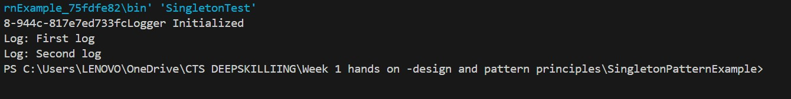
Exercise 2: Implementing the Factory Method Pattern
Document.java
interface Document {
void open();
}

WordDocument.java
class WordDocument implements Document {
public void open() {
System.out.println("Opening Word Document");
}
}

PdfDocument.java
class PdfDocument implements Document {
public void open() {
System.out.println("Opening PDF Document");
}
}

ExcelDocument.java
class ExcelDocument implements Document {
public void open() {
System.out.println("Opening Excel Document");
}
}

DocumentFactory.java
abstract class DocumentFactory {
abstract Document createDocument();
}

WordFactory.java
class WordFactory extends DocumentFactory {
public Document createDocument() {
return new WordDocument();
}
}

PdfFactory.java
class PdfFactory extends DocumentFactory {
public Document createDocument() {
return new PdfDocument();
}
}

ExcelFactory.java
class ExcelFactory extends DocumentFactory {
public Document createDocument() {
return new ExcelDocument();
}
}

FactoryTest.java
public class FactoryTest {
public static void main(String[] args) {
DocumentFactory factory = new WordFactory();
Document doc1 = factory.createDocument();
doc1.open();

factory = new PdfFactory();
Document doc2 = factory.createDocument();
doc2.open();

factory = new ExcelFactory();
Document doc3 = factory.createDocument();
doc3.open();
}
}

OUTPUT

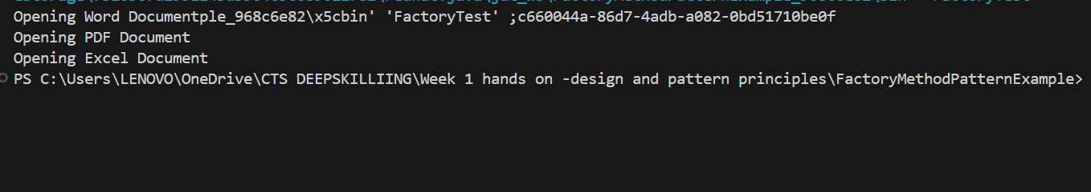

Exercise 3: Implementing the Builder Pattern
BuilderTest.java
public class BuilderTest {
public static void main(String[] args) {
Computer comp1 = new Computer.Builder()
.setCPU("Intel i5")
.setRAM("8GB")
.setStorage("512GB SSD")
.build();

comp1.showConfig();
}
}

Computer.java
class Computer {
private String CPU;
private String RAM;
private String storage;

private Computer(Builder builder) {
this.CPU = builder.CPU;
this.RAM = builder.RAM;
this.storage = builder.storage;
}

public static class Builder {
private String CPU;
private String RAM;
private String storage;

public Builder setCPU(String CPU) {
this.CPU = CPU;
return this;
}

public Builder setRAM(String RAM) {
this.RAM = RAM;
return this;
}

public Builder setStorage(String storage) {
this.storage = storage;
return this;
}

public Computer build() {
return new Computer(this);
}
}

public void showConfig() {
System.out.println("CPU: " + CPU);
System.out.println("RAM: " + RAM);
System.out.println("Storage: " + storage);
}
}

OUTPUT
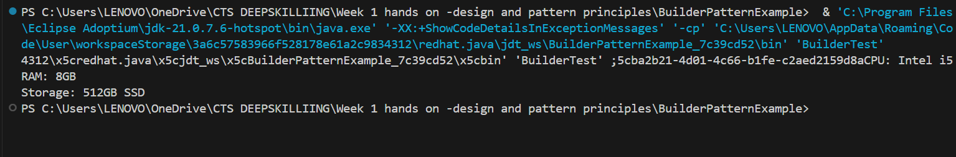
Exercise 4: Implementing the Adapter Pattern
AdapterTest.java
public class AdapterTest {
public static void main(String[] args) {
OldGateway oldGateway = new OldGateway();
PaymentProcessor adapter = new NewGatewayAdapter(oldGateway);
adapter.processPayment(500.0);
}
}

NewGatewayAdapter.java
class NewGatewayAdapter implements PaymentProcessor {
private OldGateway oldGateway;

public NewGatewayAdapter(OldGateway oldGateway) {
this.oldGateway = oldGateway;
}

public void processPayment(double amount) {
oldGateway.makePayment(amount);
}
}

OldGateway.java
class OldGateway {
public void makePayment(double amount) {
System.out.println("Payment of Rs." + amount + " processed by OldGateway");
}
}

PaymaentProcessor.java
interface PaymentProcessor {
void processPayment(double amount);
}

OUTPUT
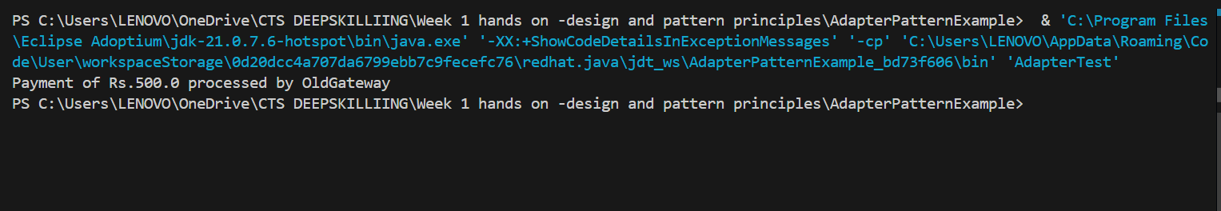
Exercise 5: Implementing the Decorator Pattern
DecoratorTest.java
public class DecoratorTest {
public static void main(String[] args) {
Notifier notifier = new EmailNotifier();
Notifier smsNotifier = new SMSNotifierDecorator(notifier);
Notifier slackNotifier = new SlackNotifierDecorator(smsNotifier);

slackNotifier.send("System Alert!");
}
}

EmailNotifier.java
class EmailNotifier implements Notifier {
public void send(String message) {
System.out.println("Email sent: " + message);
}
}

Notifier.java
interface Notifier {
void send(String message);
}

NotifierDecorator.java
abstract class NotifierDecorator implements Notifier {
protected Notifier notifier;

public NotifierDecorator(Notifier notifier) {
this.notifier = notifier;
}

public void send(String message) {
notifier.send(message);
}
}

SlackNotifierDecorator.java
class SlackNotifierDecorator extends NotifierDecorator {
public SlackNotifierDecorator(Notifier notifier) {
super(notifier);
}

public void send(String message) {
super.send(message);
System.out.println("Slack message sent: " + message);
}
}

SMSNotifierDecorator.java
class SMSNotifierDecorator extends NotifierDecorator {
public SMSNotifierDecorator(Notifier notifier) {
super(notifier);
}

public void send(String message) {
super.send(message);
System.out.println("SMS sent: " + message);
}
}

OUTPUT
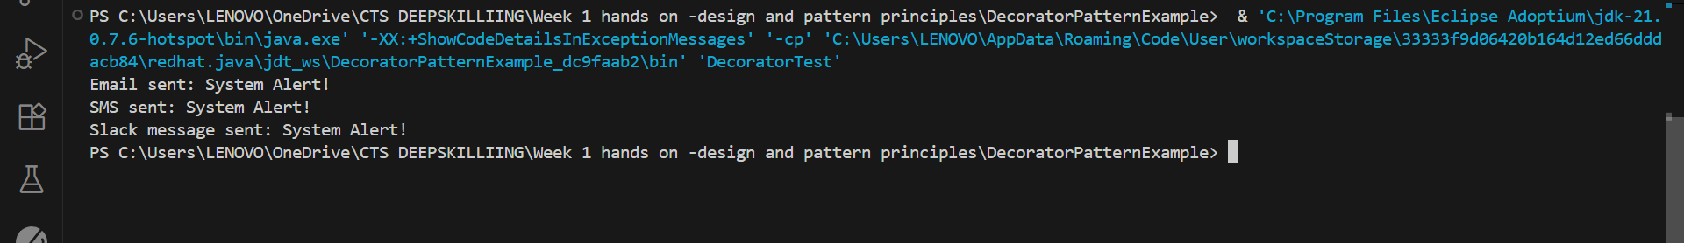

Exercise 6: Implementing the Proxy Pattern
Image.java
interface Image {
void display();
}

ProxyImage.java
class ProxyImage implements Image {
private RealImage realImage;
private String filename;

public ProxyImage(String filename) {
this.filename = filename;
}

public void display() {
if (realImage == null) {
realImage = new RealImage(filename);
}
realImage.display();
}
}

Proxytest.java
public class ProxyTest {
public static void main(String[] args) {
Image image = new ProxyImage("dog.jpeg");
image.display();
image.display();
}
}
RealImage.java
class RealImage implements Image {
private String filename;

public RealImage(String filename) {
this.filename = filename;
loadFromDisk();
}

private void loadFromDisk() {
System.out.println("Loading " + filename);
}

public void display() {
System.out.println("Displaying " + filename);
}
}

dog.jpeg


OUTPUT
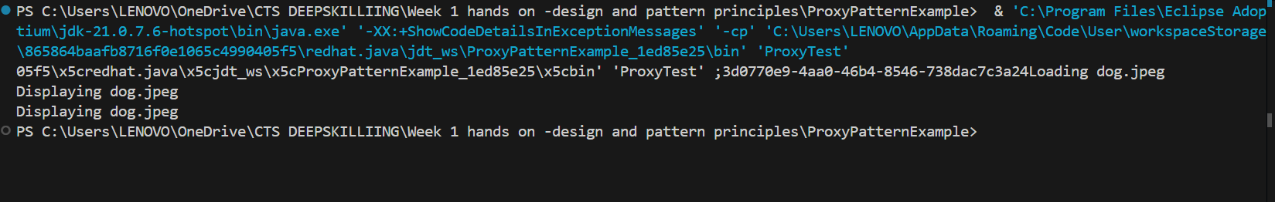

Exercise 7: Implementing the Observer Pattern
MobileApp.java
class MobileApp implements Observer {
public void update(float price) {
System.out.println("Mobile App: New stock price = Rs." + price);
}
}

Observer.java
interface Observer {
void update(float price);
}

ObserverTest.java
public class ObserverTest {
public static void main(String[] args) {
StockMarket market = new StockMarket();
Observer mobile = new MobileApp();
Observer web = new WebApp();

market.register(mobile);
market.register(web);

market.setPrice(101.5f);
}
}

Stock.java
interface Stock {
void register(Observer o);
void unregister(Observer o);
void notifyObservers();
}

StockMarket.java
import java.util.*;
class StockMarket implements Stock {
private List<Observer> observers = new ArrayList<>();
private float price;

public void register(Observer o) {
observers.add(o);
}

public void unregister(Observer o) {
observers.remove(o);
}

public void setPrice(float price) {
this.price = price;
notifyObservers();
}

public void notifyObservers() {
for (Observer o : observers) {
o.update(price);
}
}
}

WebApp.java
class WebApp implements Observer {
public void update(float price) {
System.out.println("Web App: New stock price = Rs." + price);
}
}

OUTPUT
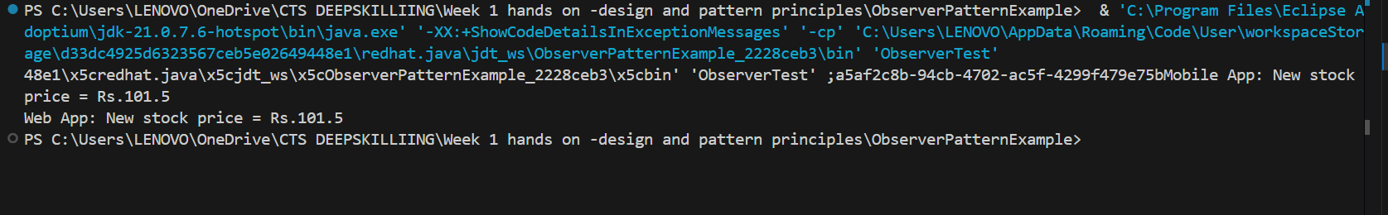

Exercise 8: Implementing the Strategy Pattern
CreditCardPayment.java
class CreditCardPayment implements PaymentStrategy {
public void pay(double amount) {
System.out.println("Paid Rs." + amount + " using Credit Card");
}
}

PaymentContext.java
class PaymentContext {
private PaymentStrategy strategy;

public void setStrategy(PaymentStrategy strategy) {
this.strategy = strategy;
}

public void pay(double amount) {
strategy.pay(amount);
}
}

PaymentStrategy.java
interface PaymentStrategy {
void pay(double amount);
}

PayPalPayment.java
class PayPalPayment implements PaymentStrategy {
public void pay(double amount) {
System.out.println("Paid Rs." + amount + " using PayPal");
}
}

StrategyTest.java
public class StrategyTest {
public static void main(String[] args) {
PaymentContext context = new PaymentContext();
context.setStrategy(new CreditCardPayment());
context.pay(300);

context.setStrategy(new PayPalPayment());
context.pay(450);
}
}

OUTPUT
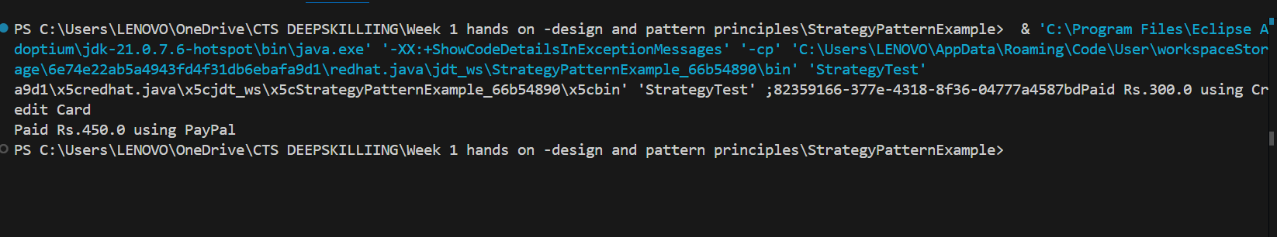

Exercise 9: Implementing the Command Pattern
Command.java
interface Command {
void execute();
}

CommandTest.java
public class CommandTest {
public static void main(String[] args) {
Light light = new Light();
Command onCommand = new LightOnCommand(light);
Command offCommand = new LightOffCommand(light);

RemoteControl remote = new RemoteControl();

remote.setCommand(onCommand);
remote.pressButton();

remote.setCommand(offCommand);
remote.pressButton();
}
}

Light.java
class Light {
public void on() {
System.out.println("Light is ON");
}

public void off() {
System.out.println("Light is OFF");
}
}

LightOffCommand.java
class LightOffCommand implements Command {
private Light light;

public LightOffCommand(Light light) {
this.light = light;
}

public void execute() {
light.off();
}
}

LightOnCommand.java
class LightOnCommand implements Command {
private Light light;

public LightOnCommand(Light light) {
this.light = light;
}

public void execute() {
light.on();
}
}

RemoteControl.java
class RemoteControl {
private Command command;

public void setCommand(Command command) {
this.command = command;
}

public void pressButton() {
command.execute();
}
}

OUTPUT
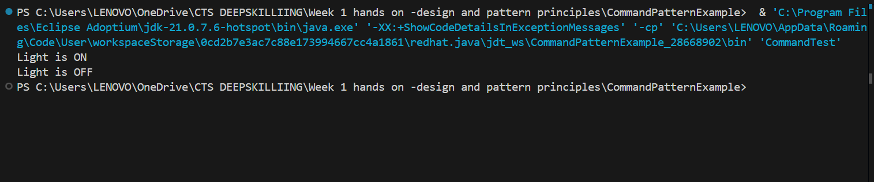

Exercise 10: Implementing the MVC Pattern
MVCTest.java
public class MVCTest {
public static void main(String[] args) {
Student student = new Student("Anu", "101", "B");
StudentView view = new StudentView();
StudentController controller = new StudentController(student, view);

controller.updateView();
controller.setStudentGrade("A+");
controller.updateView();
}
}

Student.java
class Student {
private String name;
private String id;
private String grade;

public Student(String name, String id, String grade) {
this.name = name;
this.id = id;
this.grade = grade;
}

public String getName() { return name; }
public void setName(String name) { this.name = name; }
public String getId() { return id; }
public String getGrade() { return grade; }
public void setGrade(String grade) { this.grade = grade; }
}

StudentController.java
class StudentController {
private Student model;
private StudentView view;

public StudentController(Student model, StudentView view) {
this.model = model;
this.view = view;
}

public void updateView() {
view.displayStudentDetails(model.getName(), model.getId(), model.getGrade());
}

public void setStudentGrade(String grade) {
model.setGrade(grade);
}
}

StudentView.java
class StudentView {
public void displayStudentDetails(String name, String id, String grade) {
System.out.println("Student: " + name + ", ID: " + id + ", Grade: " + grade);
}
}

OUTPUT
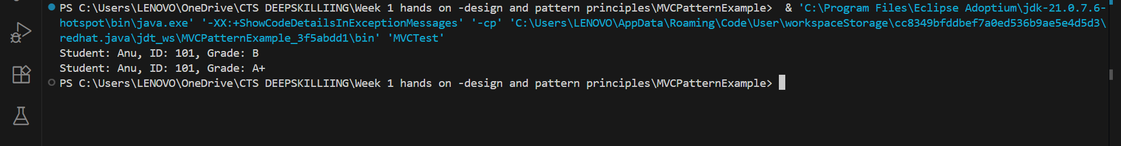

Exercise 11: Implementing Dependency Injection
CustomerRespository.java
interface CustomerRepository {
String findCustomerById(String id);
}

CustomerRespositoryImpl.java
class CustomerRepositoryImpl implements CustomerRepository {
public String findCustomerById(String id) {
return "Customer[" + id + "]";
}
}

CustomerService.java
class CustomerService {
private CustomerRepository repository;

public CustomerService(CustomerRepository repository) {
this.repository = repository;
}

public void printCustomer(String id) {
String customer = repository.findCustomerById(id);
System.out.println("Found: " + customer);
}
}

DIApp.java
public class DIApp {
public static void main(String[] args) {
CustomerRepository repo = new CustomerRepositoryImpl();
CustomerService service = new CustomerService(repo);
service.printCustomer("C102");
}
}

OUTPUT
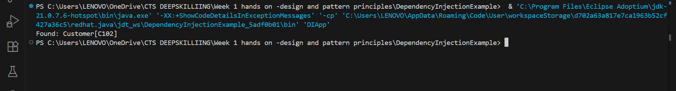

DATA STRUCTURES AND ALGORITHM

Exercise 1 Inventory Management System
import java.util.*;

class Product {
int productId;
String productName;
int quantity;
double price;

public Product(int productId, String productName, int quantity, double price) {
this.productId = productId;
this.productName = productName;
this.quantity = quantity;
this.price = price;
}
}

public class InventorySystem {
static Map<Integer, Product> inventory = new HashMap<>();

public static void addProduct(Product p) {
inventory.put(p.productId, p);
}

public static void updateProduct(int id, int quantity, double price) {
if (inventory.containsKey(id)) {
Product p = inventory.get(id);
p.quantity = quantity;
p.price = price;
}
}

public static void deleteProduct(int id) {
inventory.remove(id);
}

public static void main(String[] args) {
addProduct(new Product(1, "Laptop", 10, 55000));
addProduct(new Product(2, "Mouse", 25, 500));
updateProduct(2, 30, 520);
deleteProduct(1);
for (Product p : inventory.values()) {
System.out.println(p.productId + " " + p.productName + " " + p.quantity + " " + p.price);
}
}
}

OUTPUT
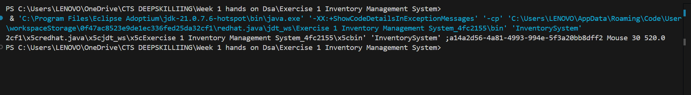

Exercise 2: E-commerce Platform Search Function
SearchFunction.java
import java.util.*;

class ProductSearch {
int productId;
String productName;
String category;

public ProductSearch(int productId, String productName, String category) {
this.productId = productId;
this.productName = productName;
this.category = category;
}
}

public class SearchFunction {
static ProductSearch[] products = {
new ProductSearch(1, "Laptop", "Electronics"),
new ProductSearch(2, "Keyboard", "Electronics"),
new ProductSearch(3, "Book", "Stationery")
};

public static int linearSearch(String name) {
for (int i = 0; i < products.length; i++) {
if (products[i].productName.equalsIgnoreCase(name)) return i;
}
return -1;
}

public static int binarySearch(String name) {
Arrays.sort(products, (a, b) -> a.productName.compareToIgnoreCase(b.productName));
int low = 0, high = products.length - 1;
while (low <= high) {
int mid = (low + high) / 2;
int cmp = products[mid].productName.compareToIgnoreCase(name);
if (cmp == 0) return mid;
else if (cmp < 0) low = mid + 1;
else high = mid - 1;
}
return -1;
}

public static void main(String[] args) {
System.out.println("Linear Search Index: " + linearSearch("Keyboard"));
System.out.println("Binary Search Index: " + binarySearch("Keyboard"));
}
}

OUTPUT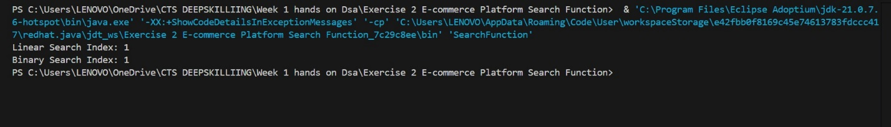

Exercise 3 Sorting Customer Orders
class Order {
int orderId;
String customerName;
double totalPrice;

public Order(int orderId, String customerName, double totalPrice) {
this.orderId = orderId;
this.customerName = customerName;
this.totalPrice = totalPrice;
}
}

public class SortOrders {
static Order[] orders = {
new Order(1, "Alice", 2500),
new Order(2, "Bob", 1500),
new Order(3, "Charlie", 3500)
};

public static void quickSort(int low, int high) {
if (low < high) {
int pi = partition(low, high);
quickSort(low, pi - 1);
quickSort(pi + 1, high);
}
}

public static int partition(int low, int high) {
double pivot = orders[high].totalPrice;
int i = low - 1;
for (int j = low; j < high; j++) {
if (orders[j].totalPrice < pivot) {
i++;
Order temp = orders[i];
orders[i] = orders[j];
orders[j] = temp;
}
}
Order temp = orders[i + 1];
orders[i + 1] = orders[high];
orders[high] = temp;
return i + 1;
}

public static void printOrders() {
for (Order o : orders)
System.out.println(o.orderId + " " + o.customerName + " " + o.totalPrice);
}

public static void main(String[] args) {
System.out.println("Before sorting:");
printOrders();
quickSort(0, orders.length - 1);
System.out.println("After sorting:");
printOrders();
}
}
OUTPUT
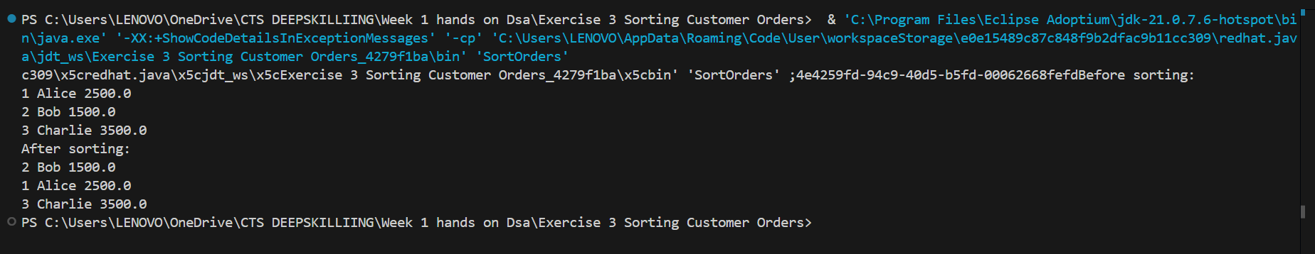

Exercise 4 Employee Management System
class Employee {
int employeeId;
String name;
String position;
double salary;

public Employee(int employeeId, String name, String position, double salary) {
this.employeeId = employeeId;
this.name = name;
this.position = position;
this.salary = salary;
}
}

public class EmployeeSystem {
static Employee[] employees = new Employee[100];
static int count = 0;

public static void addEmployee(Employee e) {
employees[count++] = e;
}

public static void searchEmployee(int id) {
for (int i = 0; i < count; i++) {
if (employees[i].employeeId == id) {
System.out.println("Found: " + employees[i].name);
return;
}
}
System.out.println("Not found");
}

public static void deleteEmployee(int id) {
for (int i = 0; i < count; i++) {
if (employees[i].employeeId == id) {
for (int j = i; j < count - 1; j++) {
employees[j] = employees[j + 1];
}
count--;
System.out.println("Deleted");
return;
}
}
}

public static void traverseEmployees() {
for (int i = 0; i < count; i++) {
System.out.println(employees[i].name);
}
}

public static void main(String[] args) {
addEmployee(new Employee(101, "John", "Manager", 50000));
addEmployee(new Employee(102, "Jane", "Clerk", 30000));
searchEmployee(101);
deleteEmployee(101);
traverseEmployees();
}
}
OUTPUT
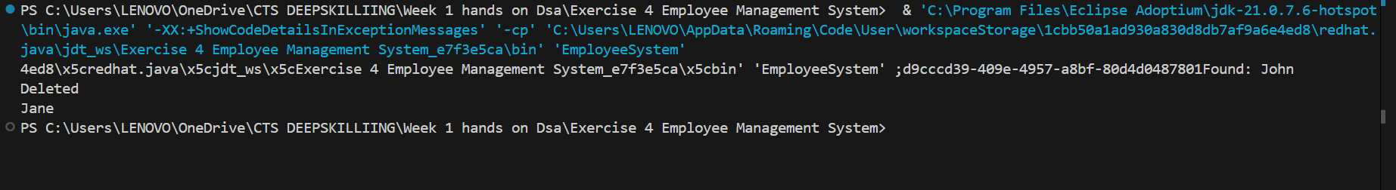
Exercise 5 Task Management System
class Task {
int taskId;
String taskName;
String status;
Task next;

public Task(int taskId, String taskName, String status) {
this.taskId = taskId;
this.taskName = taskName;
this.status = status;
this.next = null;
}
}

public class TaskManager {
static Task head = null;

public static void addTask(Task newTask) {
newTask.next = head;
head = newTask;
}

public static void traverseTasks() {
Task temp = head;
while (temp != null) {
System.out.println(temp.taskName + " - " + temp.status);
temp = temp.next;
}
}

public static void deleteTask(int id) {
if (head == null) return;
if (head.taskId == id) {
head = head.next;
return;
}
Task current = head;
while (current.next != null && current.next.taskId != id) {
current = current.next;
}
if (current.next != null) {
current.next = current.next.next;
}
}

public static void main(String[] args) {
addTask(new Task(1, "Design", "Pending"));
addTask(new Task(2, "Development", "In Progress"));
deleteTask(1);
traverseTasks();
}
}

OUTPUT
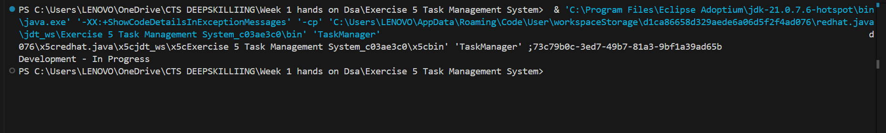

Exercise 6 Library Management System
import java.util.*;

class Book {
int bookId;
String title;
String author;

public Book(int bookId, String title, String author) {
this.bookId = bookId;
this.title = title;
this.author = author;
}
}

public class LibrarySystem {
static Book[] books = {
new Book(1, "Java Programming", "James"),
new Book(2, "Data Structures", "Alice"),
new Book(3, "Algorithms", "Bob")
};

public static int linearSearch(String title) {
for (int i = 0; i < books.length; i++) {
if (books[i].title.equalsIgnoreCase(title)) return i;
}
return -1;
}

public static int binarySearch(String title) {
Arrays.sort(books, (a, b) -> a.title.compareToIgnoreCase(b.title));
int low = 0, high = books.length - 1;
while (low <= high) {
int mid = (low + high) / 2;
int cmp = books[mid].title.compareToIgnoreCase(title);
if (cmp == 0) return mid;
else if (cmp < 0) low = mid + 1;
else high = mid - 1;
}
return -1;
}

public static void main(String[] args) {
System.out.println("Linear Search: " + linearSearch("Algorithms"));
System.out.println("Binary Search: " + binarySearch("Algorithms"));
}
}

OUTPUT
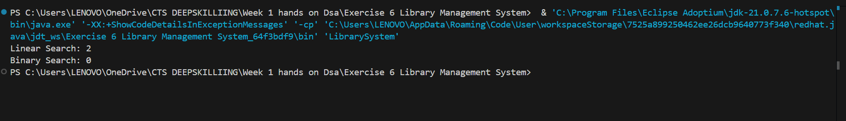

Exercise 7: Financial Forecasting
FinancialForecast.java
public class FinancialForecast {
public static double forecastValue(double currentValue, double growthRate, int years) {
if (years == 0) return currentValue;
return forecastValue(currentValue * (1 + growthRate), growthRate, years - 1);
}

public static void main(String[] args) {
double futureValue = forecastValue(10000, 0.1, 5);
System.out.println("Future Value: " + futureValue);
}
}

OUTPUT
